ANAGHA ACHARYA

1BM19CS224

**Consider the following schema for Order Database:**

**SALESMAN (*Salesman_id, Name, City, Commission*)**

**CUSTOMER (*Customer_id, Cust_Name, City, Grade, Salesman_id*)**

**ORDERS (*Ord_No, Purchase_Amt, Ord_Date, Customer_id, Salesman_id*)**

**Write SQL queries to**

**1. Count the customers with grades above Bangalore’s average.**

**2. Find the name and numbers of all salesmen who had more than one customer.**

**3. List all salesmen and indicate those who have and don’t have customers in their cities (Use UNION operation.)**

**4. Create a view that finds the salesman who has the customer with the highest order of a day.**

**5. Demonstrate the DELETE operation by removing salesman with id 1000. All his orders must also be deleted.**

create database orders;

use orders;

create table salesman(

salesman_id int,

name varchar(20),

city varchar(20),

commission varchar(20),

primary key(salesman_id));

desc salesman;

create table customer(

customer_id int,

cust_name varchar(20),

city varchar(20),

grade int,

salesman_id int,

primary key(customer_id),

foreign key(salesman_id) references salesman(salesman_id) on delete set null);

desc customer;

create table orders(

ord_no int,

purchase_amt int,

ord_date date,

customer_id int,

salesman_id int,

primary key(ord_no),

foreign key(customer_id) references customer(customer_id) on delete cascade,

foreign key(salesman_id) references salesman(salesman_id) on delete cascade);

desc orders;

insert into salesman values(1000,'John','Bangalore','25%');

insert into salesman values(2000,'Ravi','Bangalore','20%');

insert into salesman values(3000,'Kumar','Mysore','15%');

insert into salesman values(4000,'Sunil','Delhi','30%');

insert into salesman values(5000,'Harsha','Hyderabad','15%');

commit;

select * from salesman;

insert into customer values(10,'Preethi','Bangalore',100,1000);

insert into customer values(11,'Vivel','Mangalore',300,1000);

insert into customer values(12,'Baskaran','Chennai',400,2000);

insert into customer values(13,'Chethan','Bangalore',200,2000);

insert into customer values(14,'Suchitra','Bangalore',400,3000);

commit;

select * from customer;

insert into orders values(50,5000,'2017-05-04',10,1000);

insert into orders values(51,450,'2017-01-20',10,2000);

insert into orders values(52,1000,'2017-02-24',13,2000);

insert into orders values(53,3500,'2017-04-13',14,3000);

insert into orders values(54,550,'2017-03-09',12,2000);

commit;

select * from orders;

#Query1

select grade,count(customer_id)

from customer

group by grade

having grade>(select avg(grade) from customer where city='Bangalore');

#Query2

select s.name,s.salesman_id

from salesman s

where 1<(select count(*) from customer where salesman_id=s.salesman_id);

#Query3

select s.salesman_id,s.name,c.cust_name,s.commission

from salesman s, customer c

where s.city=c.city

union

select s1.salesman_id,s1.name,'No match',s1.commission

from salesman s1

where not city=any(select city from customer order by city desc);

#Query4

create view highestsales

as select s.salesman_id,s.name,o.ord_date

from salesman s, orders o

where s.salesman_id=o.salesman_id

and o.purchase_amt=(select max(purchase_amt) from orders o1 where o1.ord_date=o.ord_date);

select * from highestsales;

#Query6

delete from salesman

where salesman_id=1000;

select * from salesman;

select * from customer;

select * from orders;

OUTPUT:

SALESMAN TABLE CUSTOMER TABLE

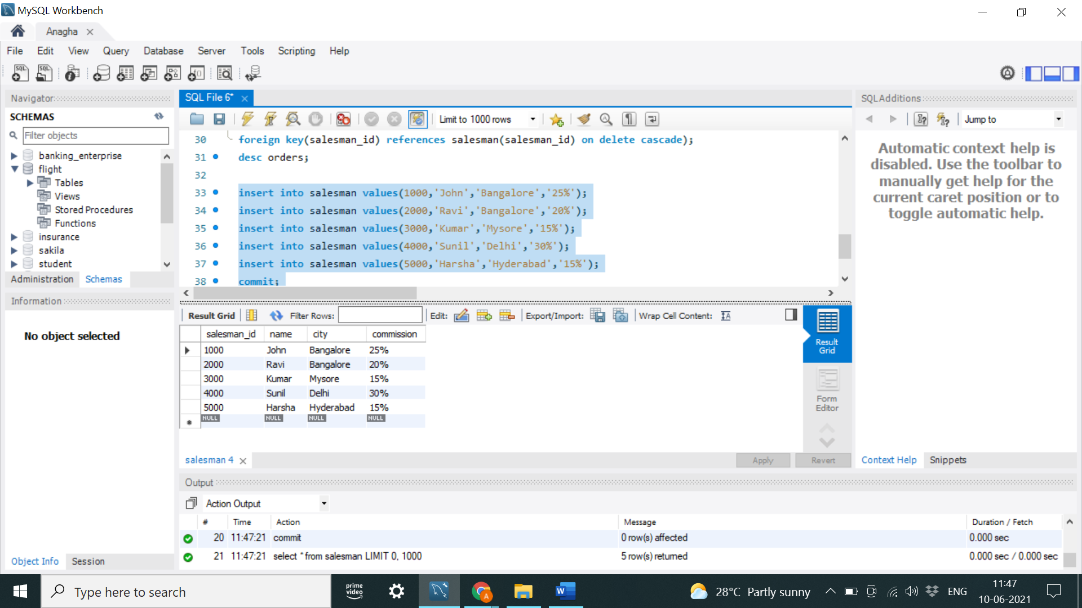 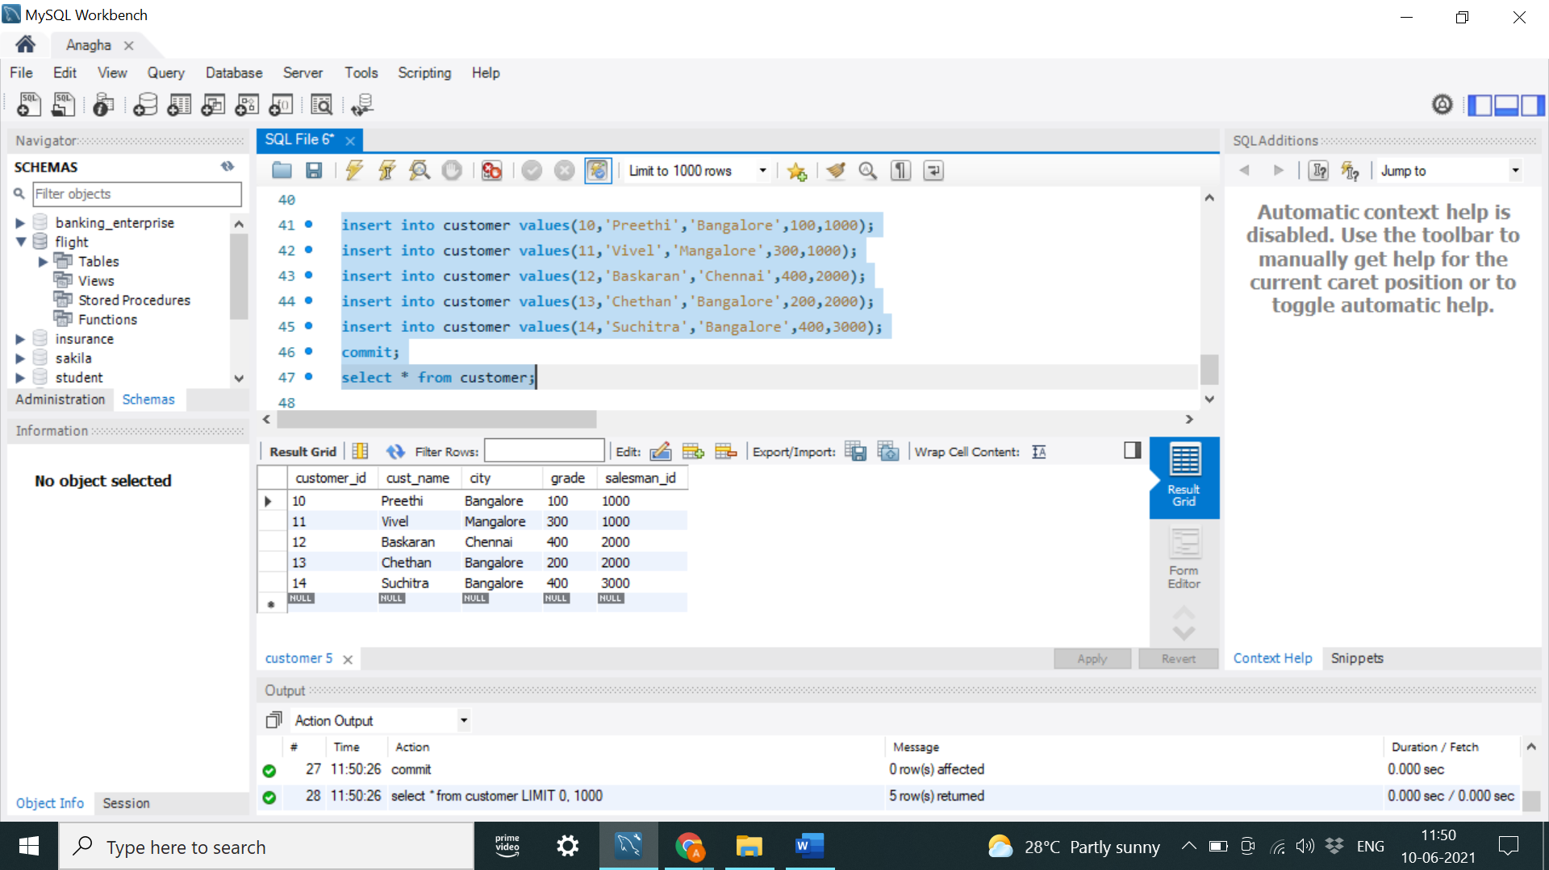

ORDERS TABLE

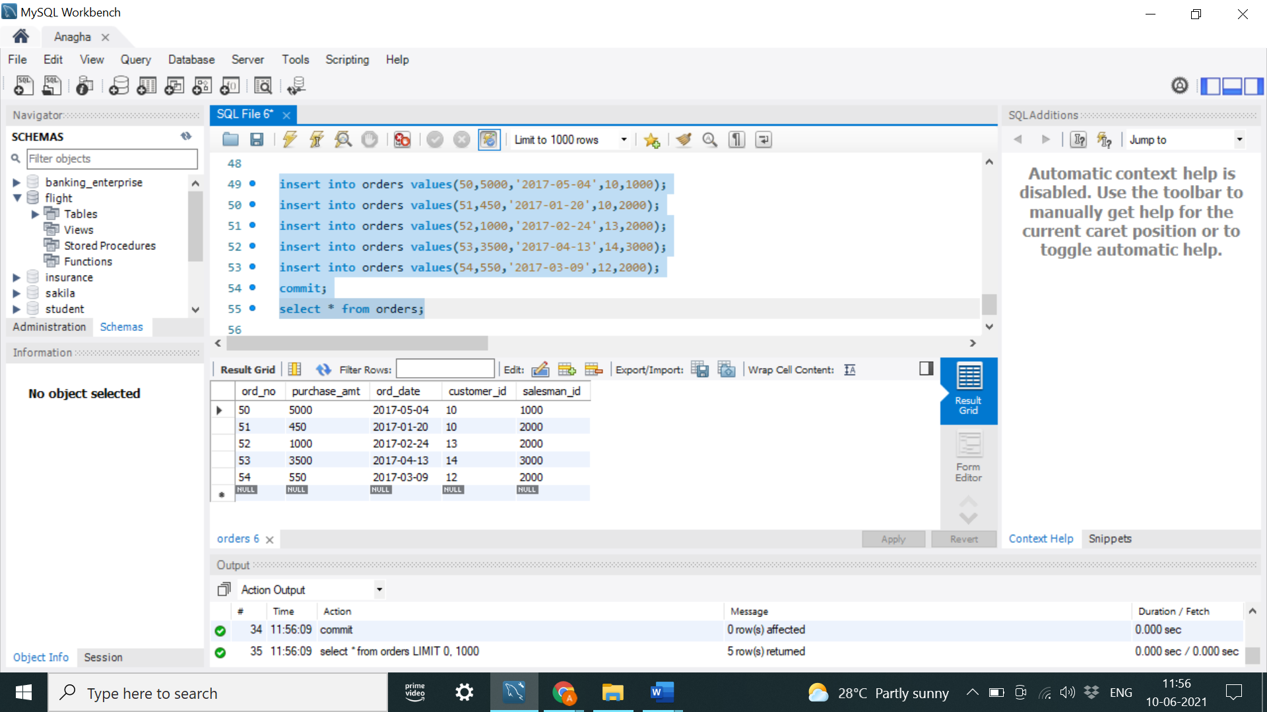

Query 1

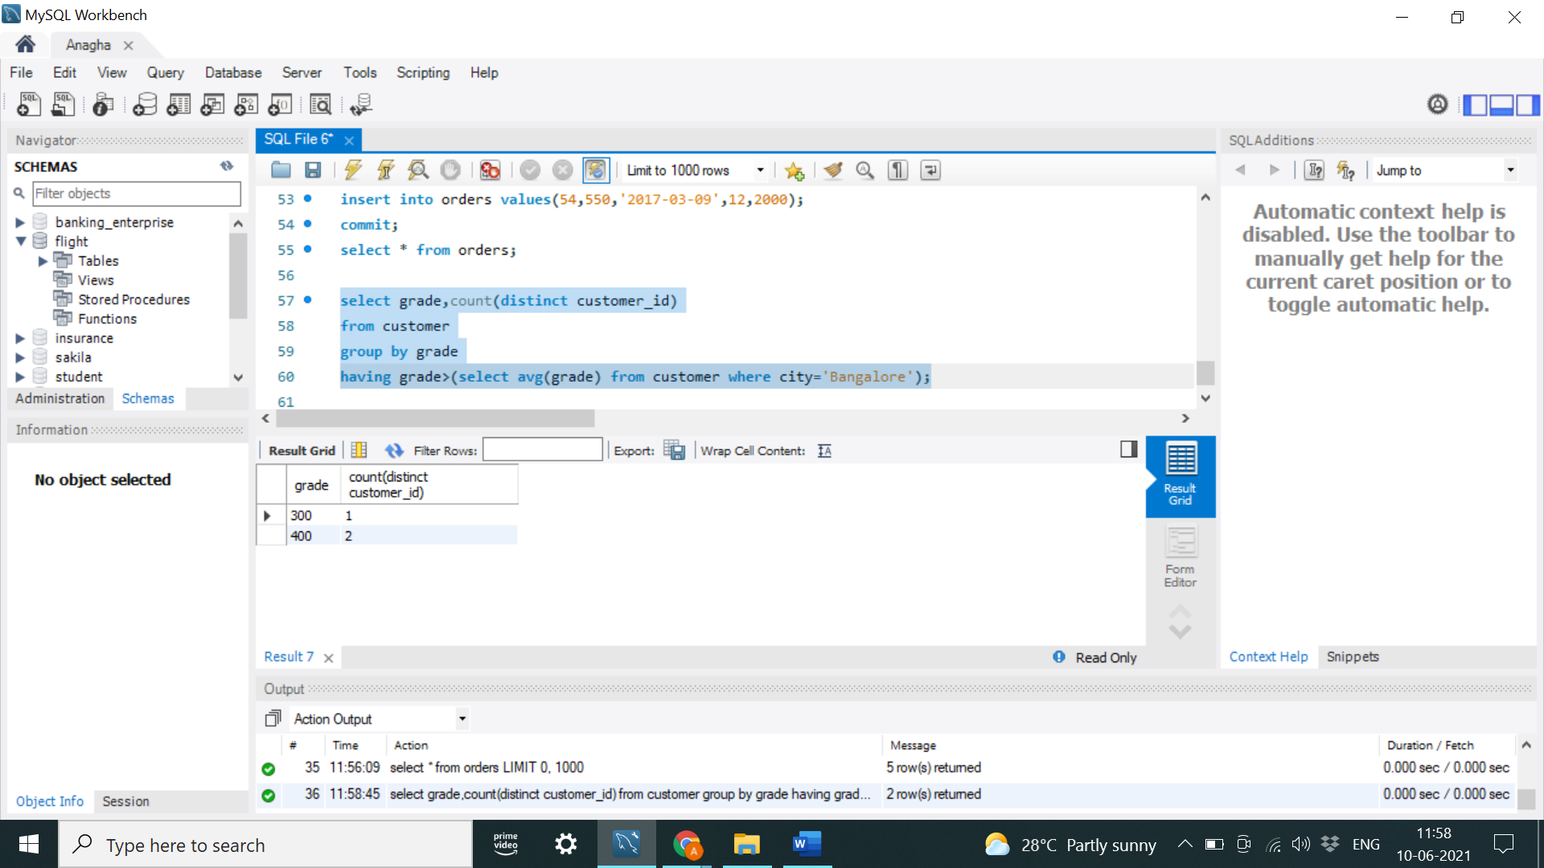

Query2

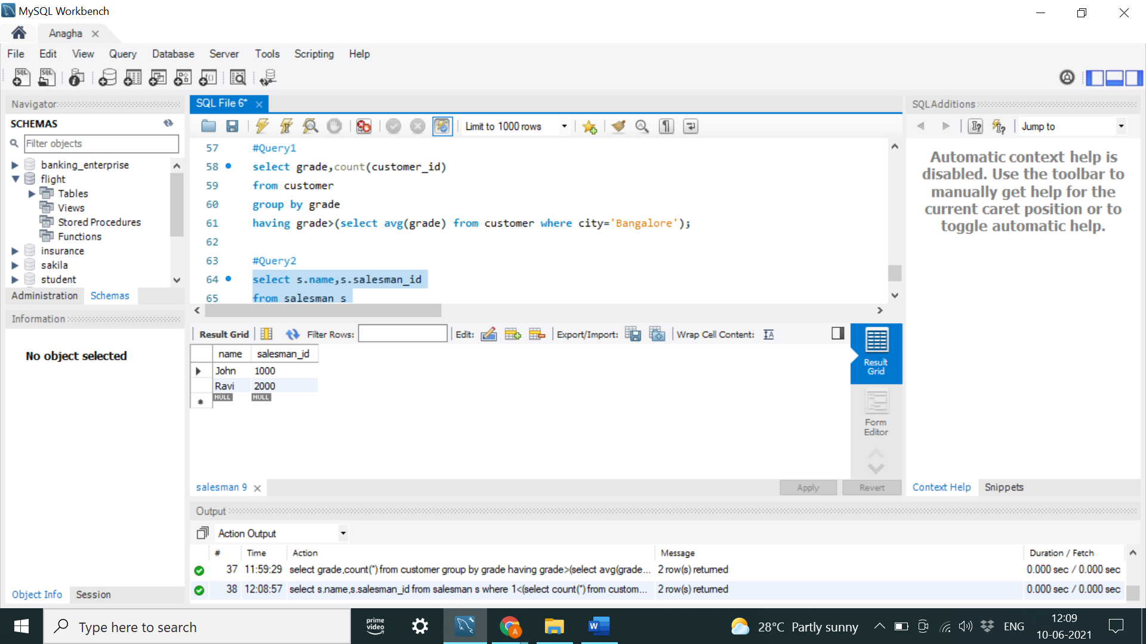

Query3

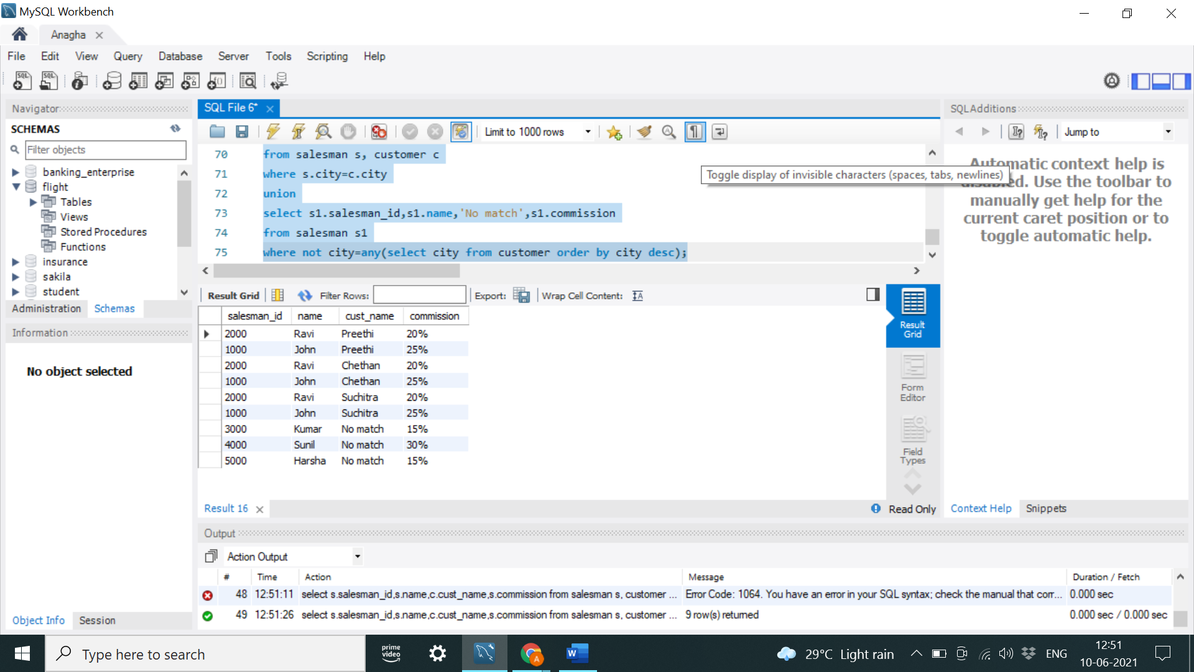

Query 4

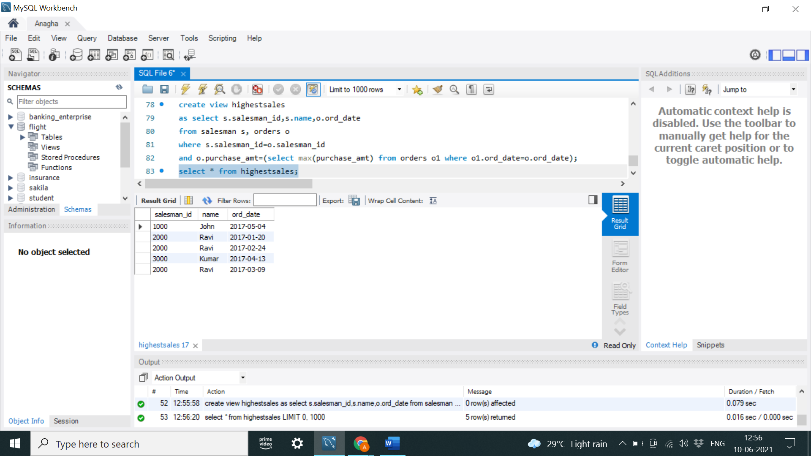

Query 5

SALESMAN TABLE CUSTOMERS TABLE

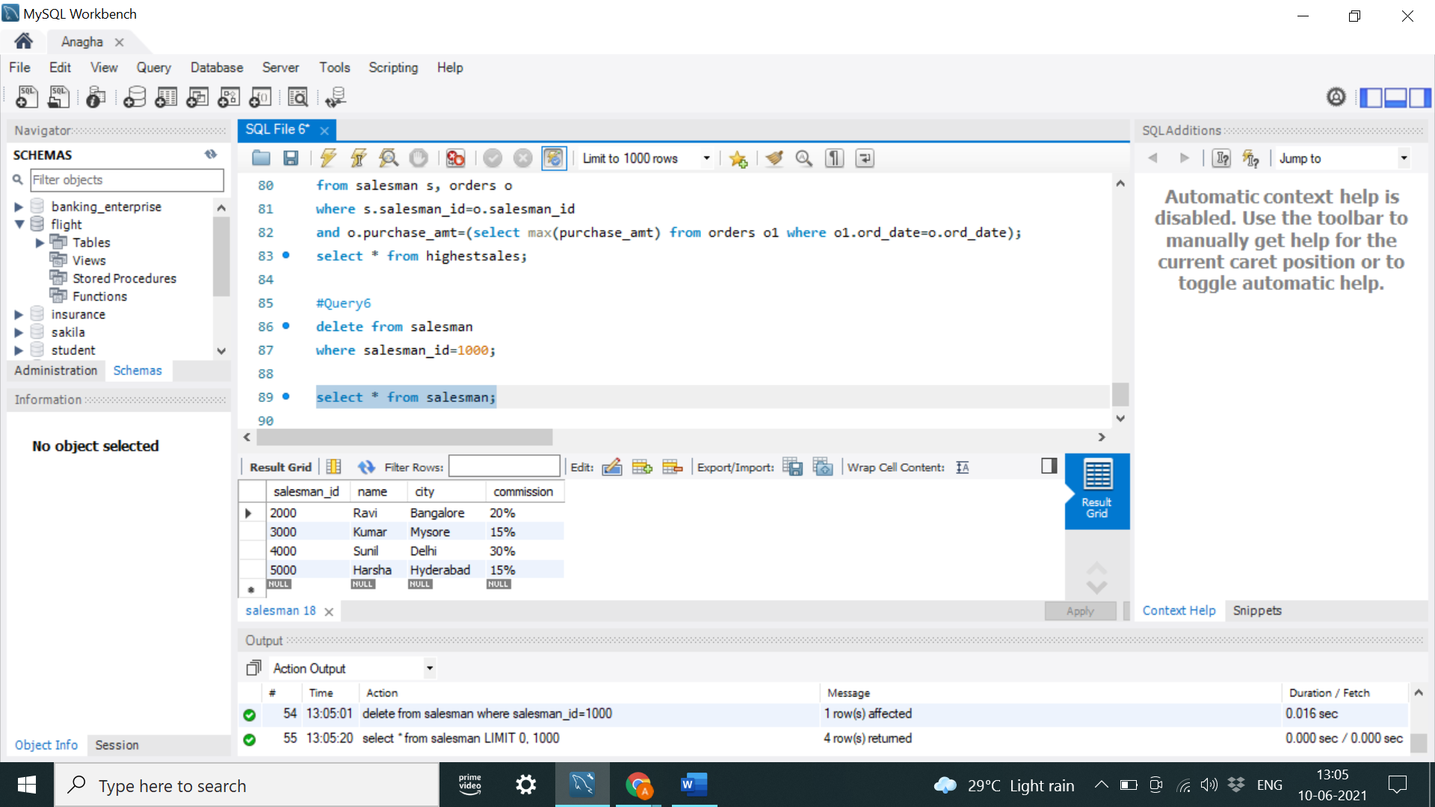 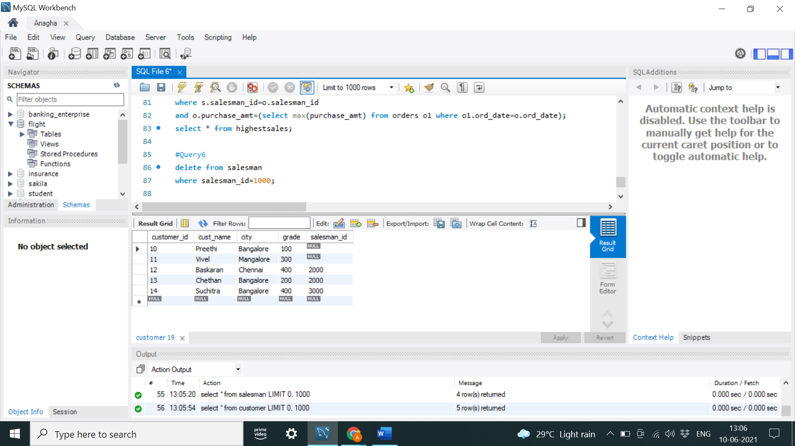

ORDERS TABLE

